WAGGLE DANCES

*A BMTC Project*



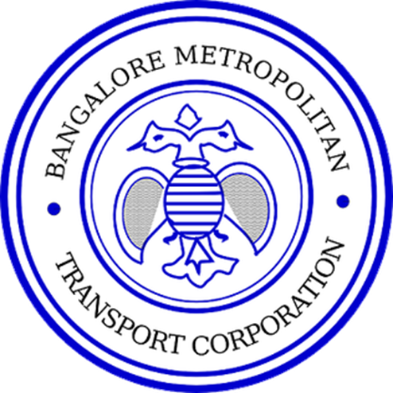

# … but what’s a waggle dance?

Studies of social insects such as bees, have resulted in a number of computational models (Optimization algorithms). Specifically, around the forager bees and their ability to find the optimal route from the hive to the source of nectar.

Once a source is found, the foragers share with other members of the colony, information about the direction and distance to patches of flowers yielding nectar and pollen, through a ritual called the “Waggle Dance”.

We draw inspiration from this, to solve the different optimization objectives for BMTC.

# The Asks

*Objective 1: Route Rationalization*

Calculate the minutes per km for every stage (Or between stops perhaps) of a given route in each corridor for a schedule timing. i.e., for every route, stage, schedule combination, what is the min/km.

*Inputs required:*

* Details of the Corridors
* Routes on each of the Corridor
* Schedule timing (Or trip time) for each route
* Criteria for Defining the Low Density and High Density

*Our Understanding:*

This can be achieved by mostly employing description analytics techniques and insights derived from which should be displayed on an interactive UI where the user will be able to change parameters – Corridor, Route, Type (Weekday or Weekend) and Condition (Peak, Non-peak etc.)

Following is the current categorization of peak/non-peak hours -

* Weekday
  + Peak (8:00 to 11:00, 16:00 to 20:00)
  + Semi-Peak (11:00 to 16:00)
  + Slack
* Weekend
  + Peak (8:00 to 11:00, 16:00 to 20:00)
  + Non-Peak

*Objective 2: Revenue Optimization*

Identify which route gives the maximum revenue for every trip. To help decide –

* The trips that should be fully cancelled
* Trips that should be partially cancelled and which stages / stops can be cancelled for that trip
* At what frequency should a route be run

Points to note that currently there is no data point on number of passengers travelling using pass.

*Inputs required:*

* Routes on each of the Corridor
* Schedule timing (Or trip time) for each route
* Date range
* Minimum number of trips to be ensured for a route

*Our Understanding:*

Provide an exploratory UI where the user can see consolidated collections and stage-wise collection for the inputs provided above.

We can also provide a “What-if” scenario for a provided “Expected Revenue” (For e.g., 70% of expected revenue) in which we can indicate the optimum schedule (Frequency) and the stops/stages to be cancelled.

*Objective 3: Fare Rationalization*

Indicate the revenue impact for a given change in fare at a particular load factor.

*Inputs required:*

* Routes on each of the Corridor
* Schedule timing (Or trip time) for each route
* Trip (Including weekday / weekend and peak/non-peak)

*Our Understanding:*

For a given set of inputs mentioned above, provide a “What-if” scenario when the fare is changed (At a stage level).

Also provide a provision to change the load factor to monitor the impact on the revenue. (In other words, how does changes to fare and ridership impact revenue)

*Objective 4: Resource Optimization*

Are buses scheduled optimally based on –

1. Ridership
2. Revenue

(This requirement was not discussed in detail and we need more conversations on this topic)

*Objective 5: Schedule Optimization*

Again, not discussed in detail, but the output we get from route rationalization can be used as an input for Schedule Optimization.

(Isn’t this extending the current existing solution provided by Gaurav and team?)

# Scope

* To be updated post discussion with professor

# Open Questions

* Do we use the IIMB infra for this ? If so, how will the application be used by BMTC ?